Computer Architecture Lab
(EL-2012)
LABORATORY REPORT

Fall 2026

(Lab#06)
Use of Venus Simulator for RISC-V Procedure Execution

Student Name: _Syed Sikandar Abbas_ Roll No: _24I-6553_ Section: CE-3B

Date performed: _September 30, 2026

MARKS AWARDED: ________ / 10

Signature and date of Instructor: _________________
Lab Instructors: Dr. Nasir Ali Shah, Engr. Fasih Ahmad

______________________________________________________________________________________________________________________________________________________

NATIONAL UNIVERSITY OF COMPUTER AND EMERGING SCIENCES, ISLAMABAD
Prepared by: | Fasih Ahmad |  | Version: 1.0
Verified by: | Dr. Nasir Ali Shah |  | Updated: Fall 2026

Task 1:

Description:
In this task we were provided with a code that wasn’t working. The code was calling a procedure which was using a saved value from the caller procedure and it was overwriting it without the caller noticing. Because of this, the caller procedure was getting a different result. To solve this, the callee procedure was altered to use temporary registers to get its own task done. In this way, the saved value from the caller was preserved and the result was obtained as intended.
Code:
.text
.globl main

main:
li a0, 1
li s0, 2500
jal ra, procedure # call procedure

add t1, s0, a0 # result should be 1003+2500

li a0, 1 # setup system call for display (command in a0)
mv a1, t1 # data to display in a1
ecall # displays result on console

li a7, 93
li a0, 10
ecall

procedure:
li t2, 3 # Use temporary register t2 instead of s0
li t0, 1000
add a0, t2, t0
ret # return
Output:
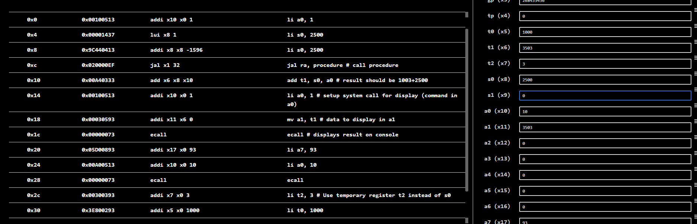

Task 2:
Description:
In this task a piece of code was provided and we were supposed to explain it. It was storing 3 values in the stack and loading it. The step-by-step explanation is provided in the code comments.
Code:
addi s0, zero, 5 # s0 = 5
addi t1, zero, 10 # t1 = 10
addi t0, zero,15 # t0 = 15
addi sp, sp, -12 # allocates three bytes in stack
sw s0, 0(sp) # save s0 (5) at stack memory address sp + 0
sw t0, 4(sp) # save t0 (15) at stack memory address sp + 4
sw t1, 8(sp) # save t1 (10) at stack memory address sp + 8
lw t4, 8(sp) # load value from sp + 8 (10) into t4
lw t2, 4(sp) # load value from sp + 4 (15) into t2
lw t3, 0(sp) # load value from sp + 0 (5) into t3
addi sp, sp, 12 # free the stack
Output:
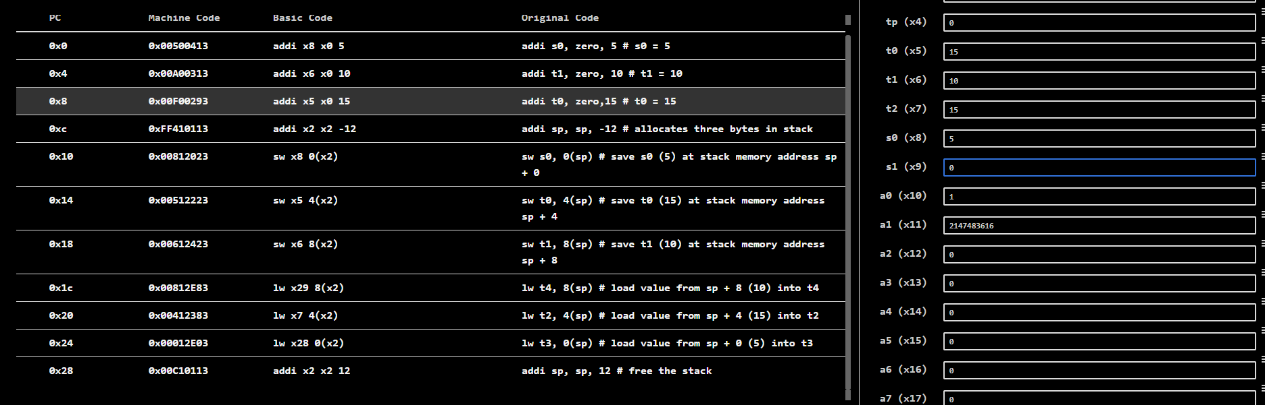

Task 3:

Description:
In this task a C code snippet was given and we were required to produce its RISC-V assembly equivalent code. It used a procedure to solve an equation.
Code:
.data
.text
main:
li a3, 5
li a4, 7

jal ra, EqSolver
j end

EqSolver:
add t0, a3, a4
sub t1, a3, a4
mul a0, t0, t1

ret

end:
Output:
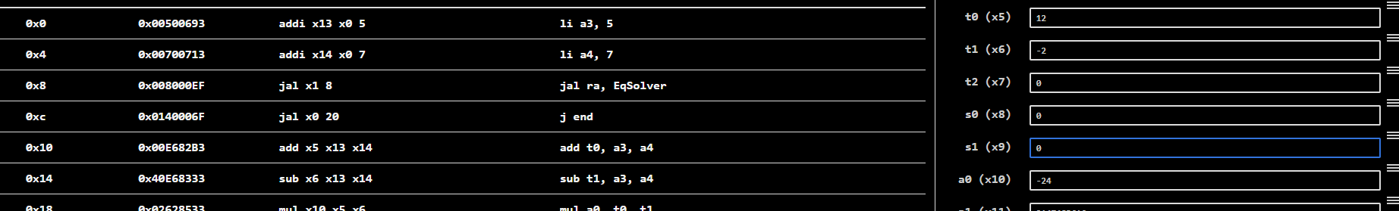

Task 4:

Description:
In this task we were asked to write a RISC-V assembly code that has two procedures, AreaFinder and PerimeterFinder which take the side and calculate the Area and Perimeter of a given square.
Code:
.data
.text
.globl main
main:
li a0, 4

jal ra, AreaFinder
mv s0, a0 # store a0 in s0. s0 is area

jal ra, PerimeterFinder
# a0 now has the perimeter
mv s1, a0

j end

AreaFinder:
mul a0, a0, a0
ret

PerimeterFinder:
li t0, 4
mul a0, a0, t0
ret

end:
Output:
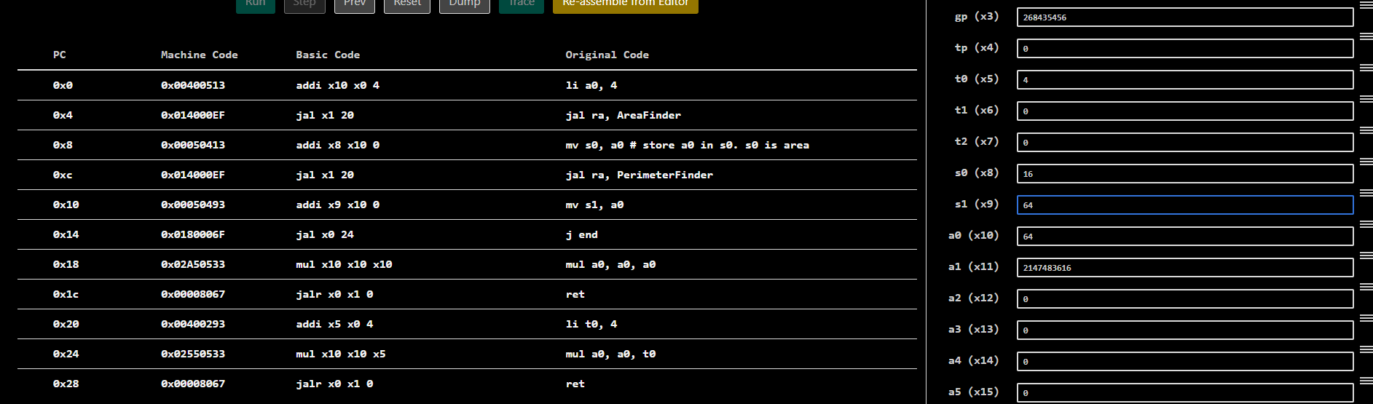

Task 5:

Description:
In this code, a C snippet was provided and we were supposed to write its RISC-V assembly equivalent code that takes a value of x and produces the value of a function at x. The polynomial was defined as
x^3 + 5x^2 + 6x.
Code:
.text
main:
li a3, 5

jal ra, EqSolver
mv s0, a0

j end

EqSolver:
# x^3+5x^2+6x
mul t0, a3, a3
mul t0, t0, a3
addi t5, x0, 5
addi t6, x0, 6
mul t1, a3, a3
mul t1, t1, t5
mul t2, t6, a3
add t3, t0, t1
add a0, t3, t2
end:
Output:
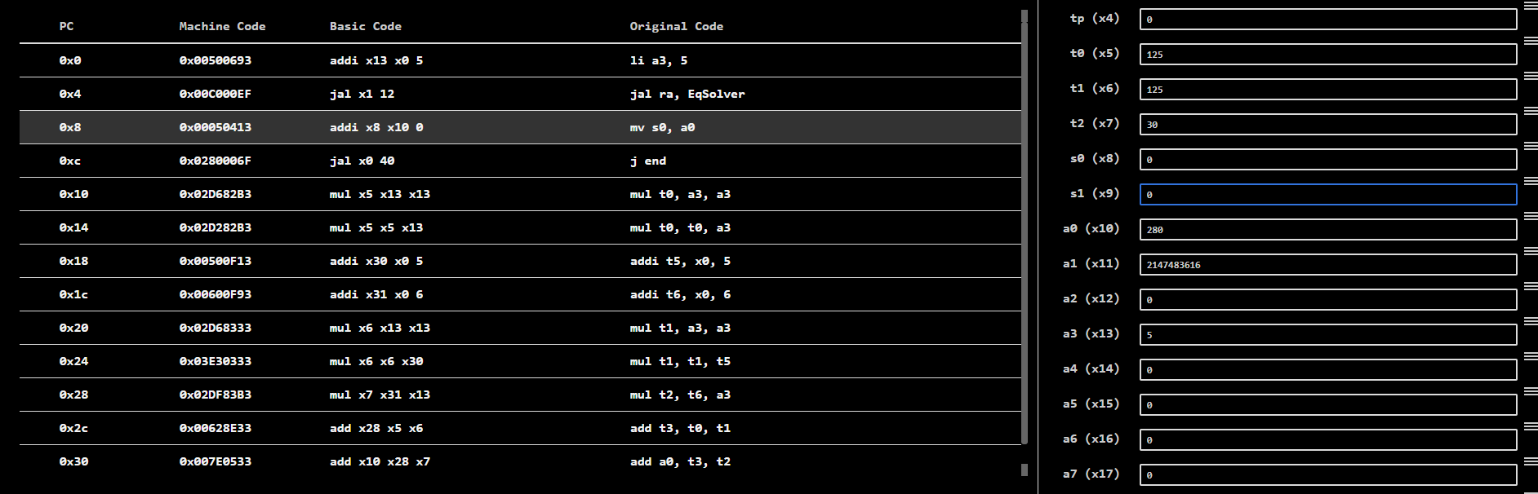

Task 6:

Description:
This task required us to write a RISC-V assembly program from a given C program. It had multiple proceduers that were to be executed in case of different values of n and k.
Code:
.text
main:
li a0, 5 # n
li a1, 7 # k

li s0, 1

beq a1, s0, callF1
bgt a0, a1, callF2
jal ra, F3
j exit
callF1:
jal ra, F1
j exit
callF2:
jal ra, F2
j exit

F1:
mul t0, a0, a0 # x2
mul t1, a1, a1 # z2
add a0, t0, t1
ret

F2:
mul t0, a0, a0 # a^2
mul a0, t0, a0 # a^2 * a = a^3
ret

F3:
addi a0, a0, 5
ret

exit:
Output:
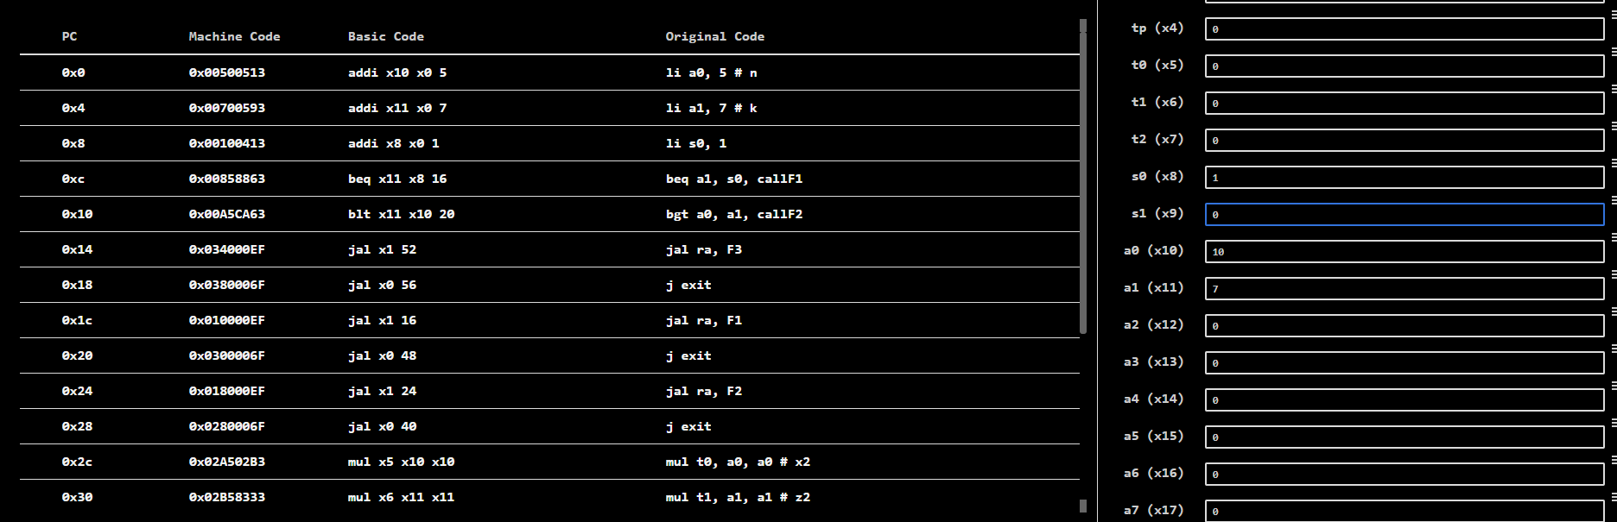

Task 7:

Description:
This task required us to write a RISC-V assembly program from a given C program. It had multiple proceduers that were to be executed in case of different values of n and k.
Code:
.text
.globl main
main:
li a0, 5 #n
li a1, 9 #k
beq a1, zero, callfun1
beq a0, a1, callfun2
jal ra, fun3
j exit
callfun1:
jal ra, fun1
j exit
callfun2:
jal ra, fun2
j exit
fun1:
mul a0, a0, a0
ret
fun2:
mul t0, a0, a0
mul a0, t0, a0
ret
fun3:
addi a0, a0, 1
ret
exit:
Output:
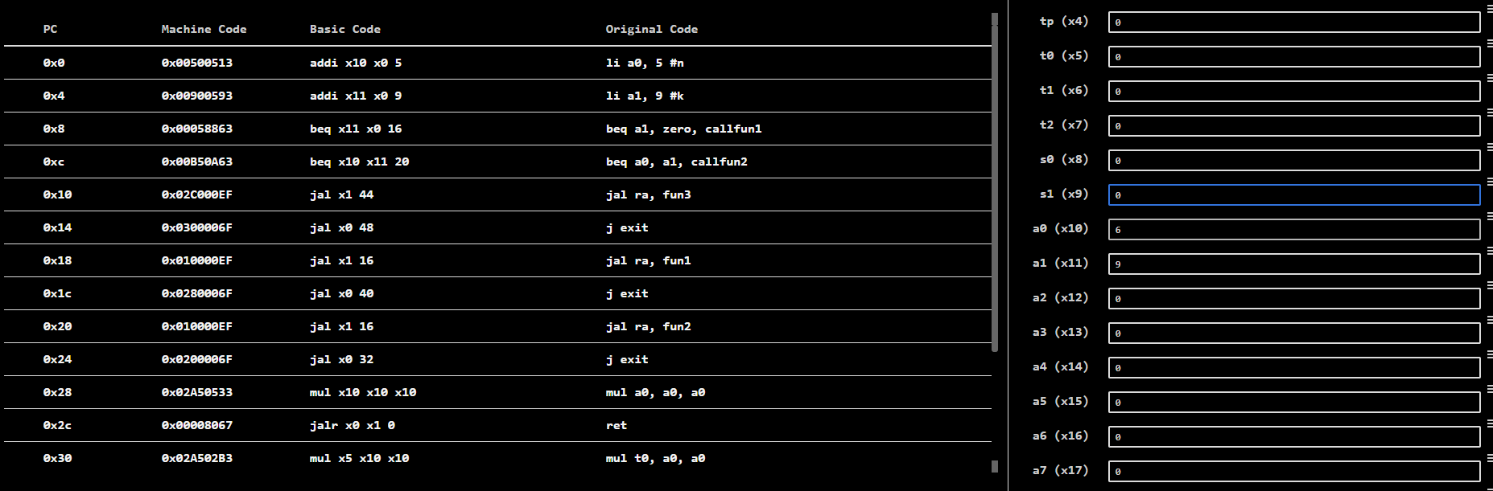

Task 8:

Description:
In this task, we were required to translate two C codes to RISC-V assembly codes to find the Fibonacci series of a number ‘n’. One code was Without recursion, using a for loop and the other one was through recursion.
Code: (Without Recursion) (With Recursion)
.text  .globl main  main:  li a0, 10 #n  jal ra, fib  j exit  fib:  li t0, 0 # a  li t1, 1 # b  li t2, 0 # c  li t3, 2 # i  bne a0, x0, Loopstart  li a0, 1  ret  Loopstart:  bgt t3, a0, Loopend  add t2, t0, t1  mv t0, t1  mv t1, t2  addi t3, t3, 1  j Loopstart  Loopend:  ret  exit: | .text  .globl main  main:  li a0, 10  jal ra, fib  j exit  fib:  beq a0, zero, ifzero  li t0, 1  beq a0, t0, ifone  addi sp, sp, -16  sw ra, 12(sp)  sw s0, 8(sp)  sw s1, 4(sp)  mv s0, a0  addi a0, s0, -1  jal ra, fib  mv s1, a0  addi a0, s0, -2  jal ra, fib  add a0, s1, a0  lw s1, 4(sp)  lw s0, 8(sp)  lw ra, 12(sp)  addi sp, sp, 16  ret  ifzero:  li a0, 0  ret  ifone:  li a0, 1  ret  exit:  li a0, 10  ecall
Output:
Without Recursion
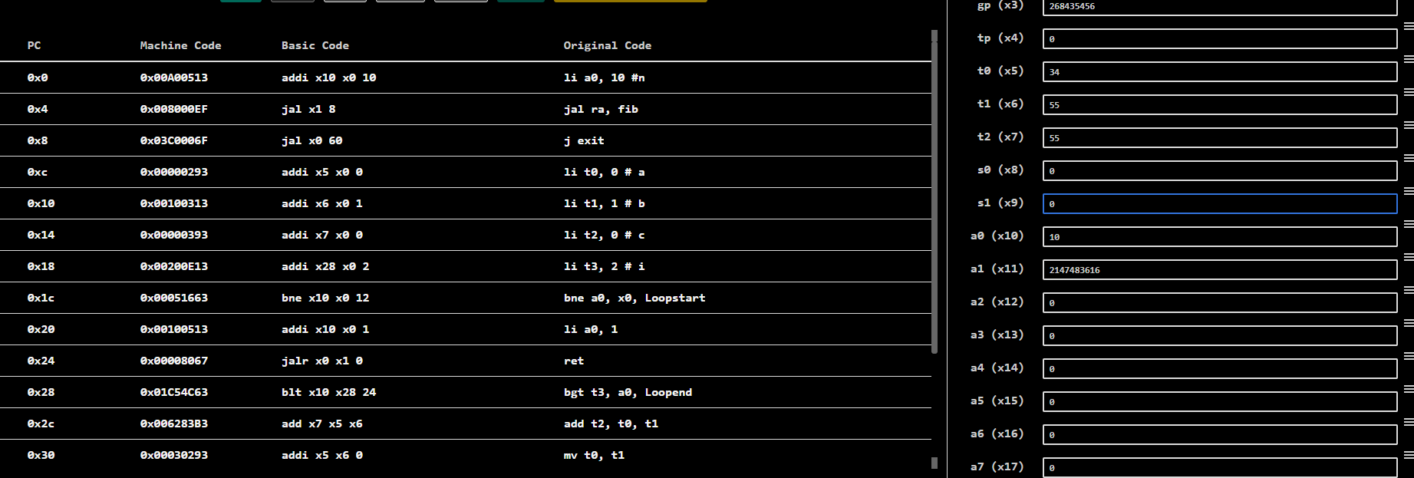

With Recursion
